
Bruce Hopkins Ltd.

Agricultural & Groundcare Engineers

Head Office & Accounts

Shenington Airfield, Banbury, Oxon, OX15 6NW

Tel: 01295 680711. E Mail-bruce@brucehopkins.co.uk



August 2019

DOMESTIC -Ex Demo, New,Used & Specials

Husqvarna Main Dealers, good range in stock – Phone for a full catalogue

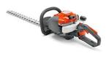
NEW Husqvarna
122 HD60
Hedge Trimmer
60cm Blade
P.O.A.

NEW Husqvarna
525RX
Strimmer
25cc
P.O.A.

NEW Husqvarna 135
Domestic Chainsaw
41cc 14” bar
P.O.A.

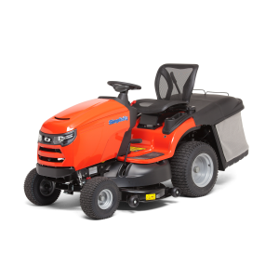

NEW Simplicity RegentRD/SRD360

42”Side Discharge deck.
c-w Mulching kit
£4,409 inc VAT

NEW Simplicity

RegentXL/SLT110

42”Side Discharge deck.

£2,294 inc VAT

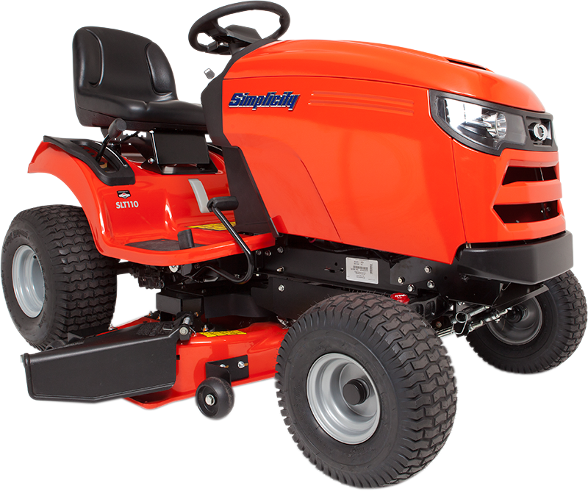
NEW Snapper RPX310
22 HP, Hydro
42” deck
Grass Collector box and
Mulch kit.
£3,779 inc VAT

£3,420 inc VAT

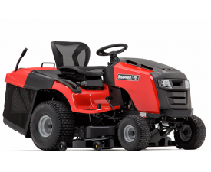
NEW Husqvarna

Rider R216T AWD, 103cm deck, 4WD, B&S twin cylinder engine, mulching or rear discharge
£4,714 inc VAT

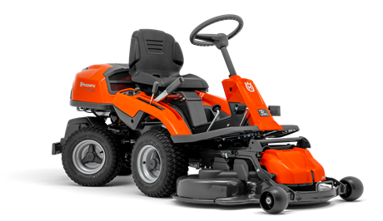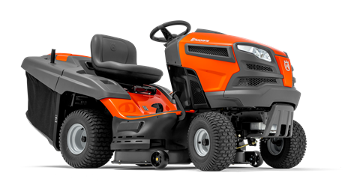
NEW Husqvarna
TS243T

107cm deck,
Side Eject

£3,000 inc VAT

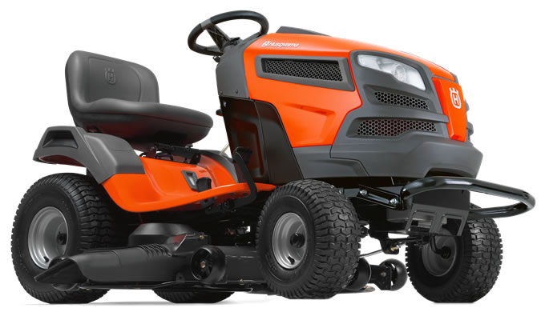
NEW Husqvarna
TC239T, Twin cylinder engine, 97cm deck, Rear grass collection box , or mulching
£3,196 inc VAT

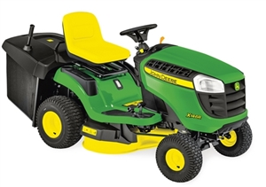
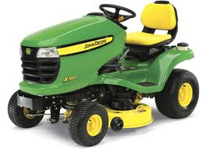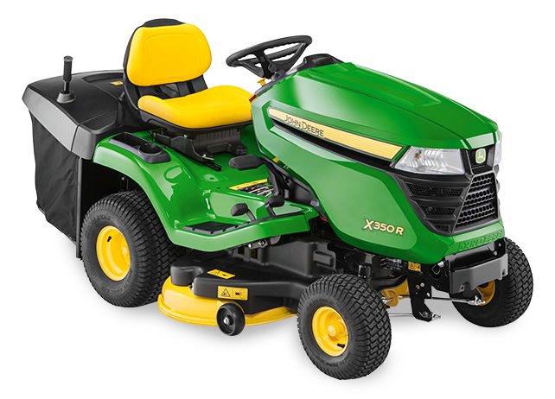
NEW JohnDeere
X146R
16.8hp Twin Cyl
Hydro, 36” cut.
Rear collector box
£3,505 inc VAT

NEW John Deere X350 17hp Twin cylinder
Hydro
42” Mulching deck

£4,514 inc VAT
NEW JohnDeere
X350R
17hp Twin cylinder
Hydro, 42” cut,
Rear collector box

£4,946 inc VAT
NEW TS98 Sweeper
36” Wide brush
270 Litre grass box
Strong construction
£1,094 inc VAT

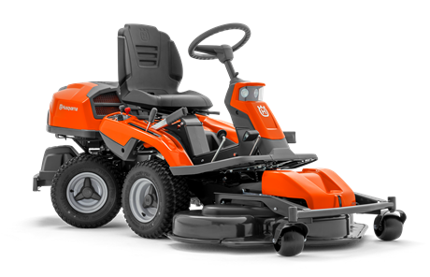
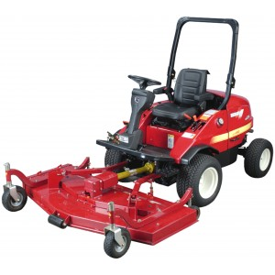
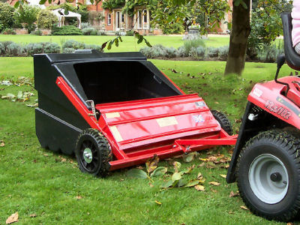
NEW Husqvarna
R316TS 4WD
112cm cut
Bioclip deck

£6,816 inc VAT

Various used ride on’s
in stock
Phone for latest list.

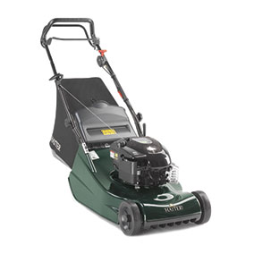
Snapper

Zero Turn ZTX275

48” Deck

£4,749 inc VAT
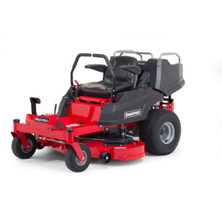
Shibaura CM374

4WD 36hp

Out front 72” deck

£20,400 inc VAT

Hayter Harrier

Model 41VS
P.O.A
Model 48VS
P.O.A.
Model 56VS
P.O.A.

For Further Details Contact Bruce Hopkins 07860 809708 Professional SEE OVER
Wanted, Good Used Quad Bikes
Bruce Hopkins Ltd.

Agricultural & Groundcare Engineers

Head Office & Accounts

Shenington Airfield, Banbury, Oxon, OX15 6NW

Tel: 01295 680711. E Mail-bruce@brucehopkins.co.uk

August 2019

PROFESSIONAL -Ex Demo, New, Used & Specials

WE HAVE A GOOD RANGE OF NEW HONDA QUAD BIKES IN STOCK

Honda Foreman 500FM2
475cc engine .
Manual Gearshift
2 or 4 wheel drive
Free Tracker
Ex Demo
£5,900 + Vat

Honda Fourtrax 420ES. 420cc engine
Electric shift gearbox
2wd or 4 wheel drive
Free Tracker
Ex Demo
£5,750 + Vat

£6,240+ VAT

Honda Fourtrax 250ES. 250cc engine
Electric shift gearbox
2 wheel drive
Free Tracker
Ex Demo
£3,900 + Vat
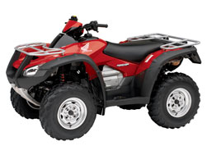
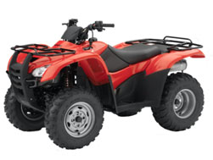

Demonstrations Available

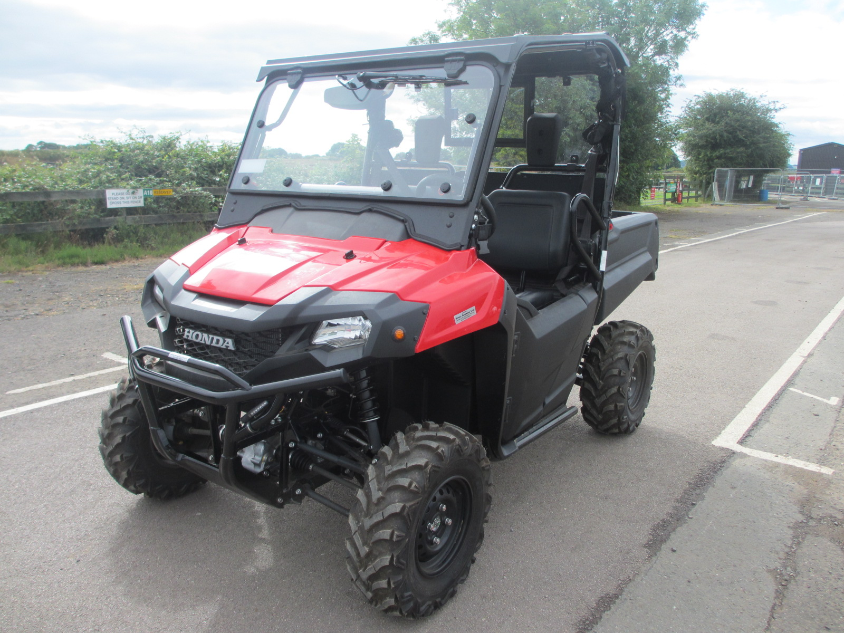
Honda Sporttrax
90cc
Ideal for Youngsters

Retail Price
£2,175 + Vat

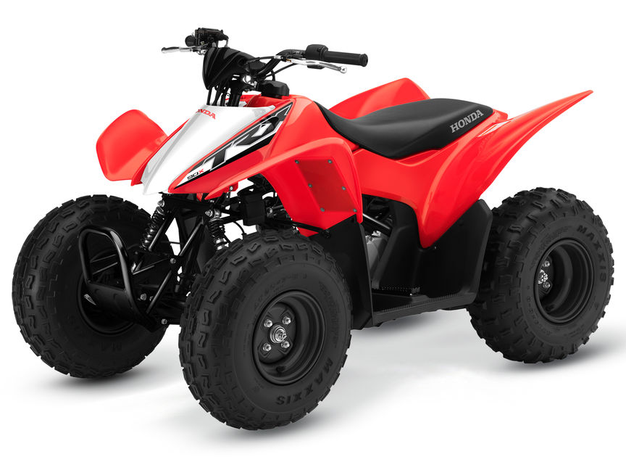
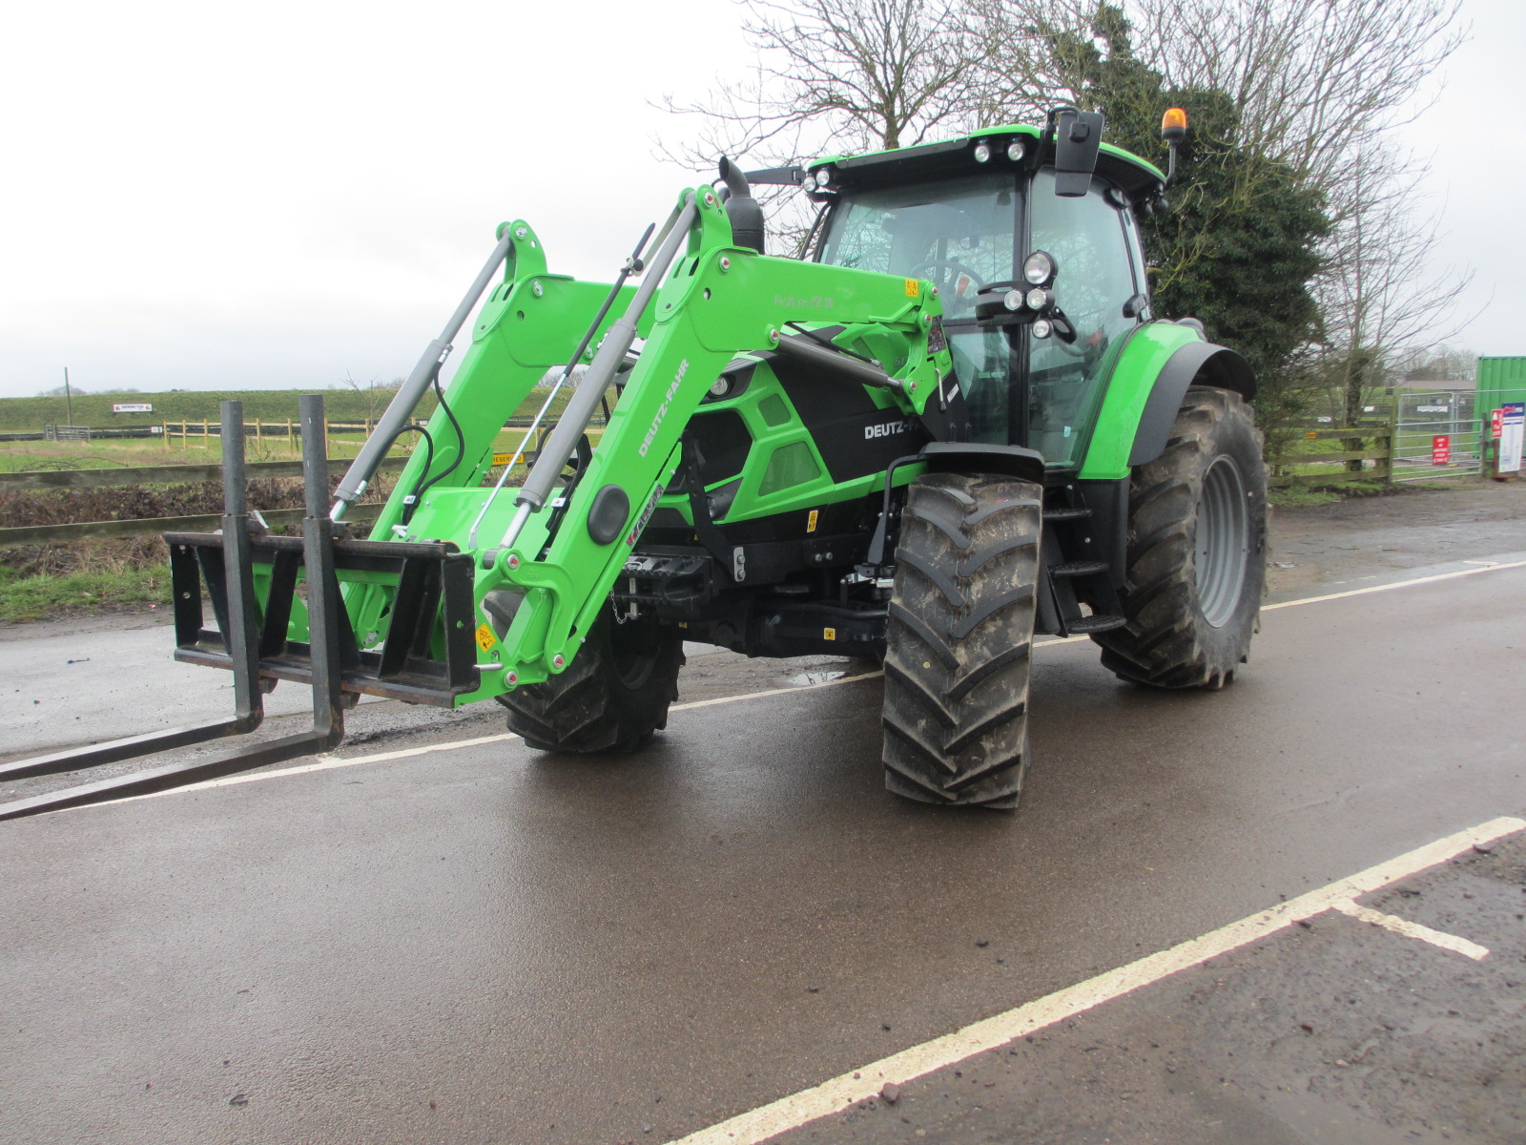Type a quote from the document or the summary of an interesting point. You can position the text box anywhere in the document. Use the Text Box Tools tab to change the formatting of the pull quote text box.]
Ex Demo Deutz
6130 130HP engine.
c/w Front Loader

£63,000 + Vat
Honda Pioneer
Utility Vehicle
2 seater
675cc
3-speed auto gearbox
Road Legal Kit
Half Cab
Retail - £13,500 + Vat
Our price
£12,500 + Vat

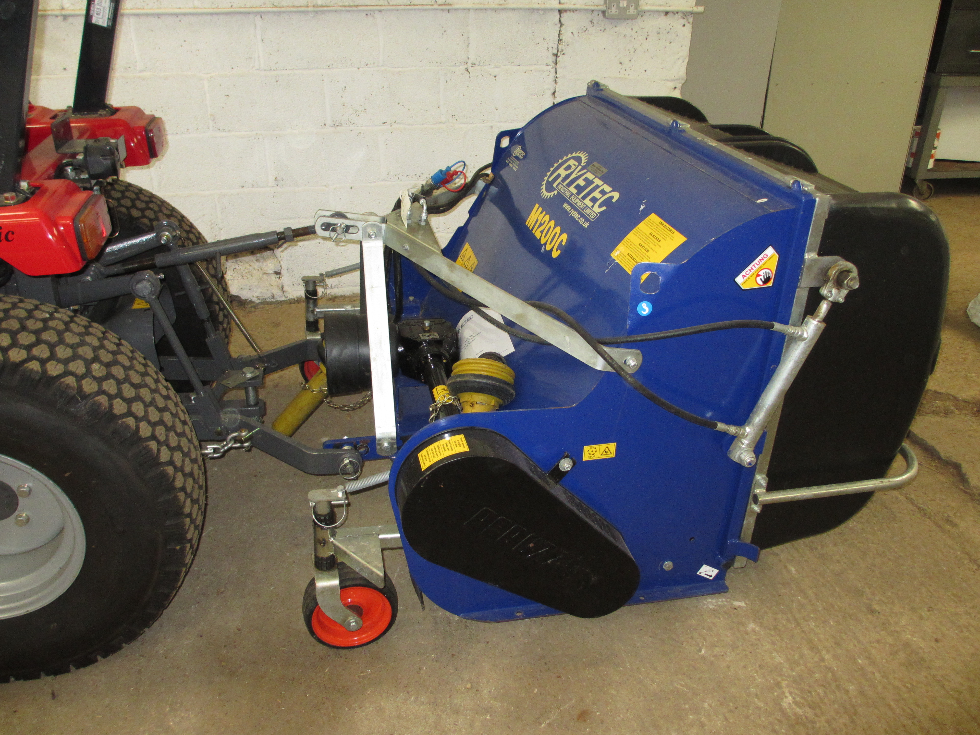
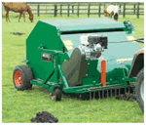
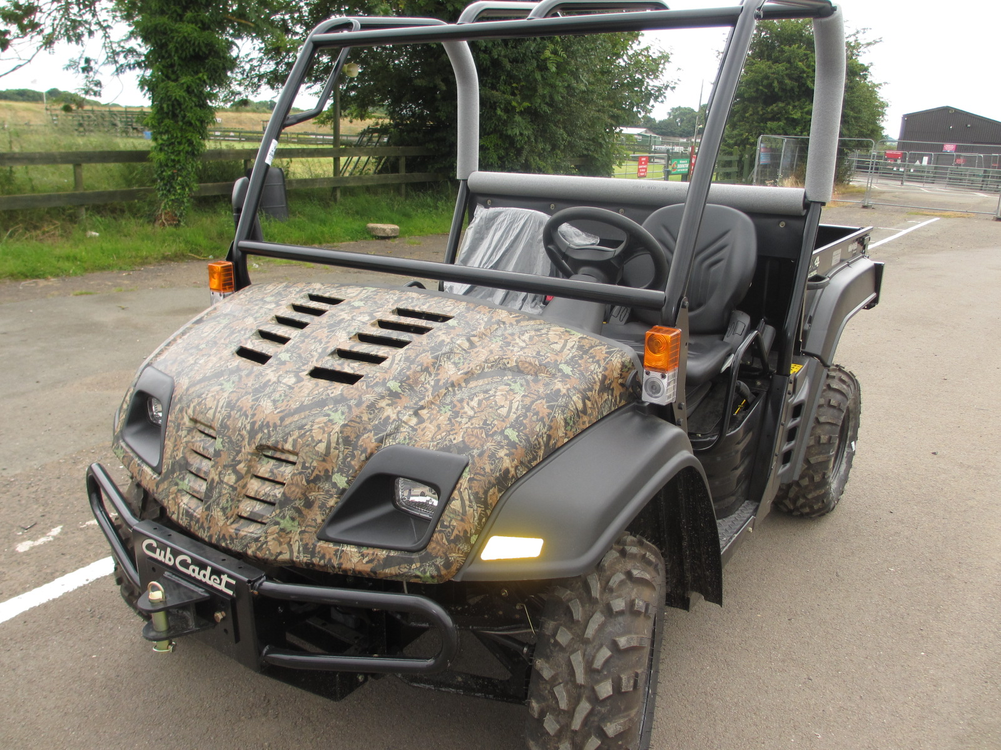

Utility Vehicle
Cub Cadet
21 hp Diesel Engine
4 x 4, Ex demo
409 kg payload 2
CVT transmission

Ex demo

£14,500 + VAT
New Rytec
Flail collectors
1.2 or 1.5 metre cut
For tractors 25hp to 50hp
POA
Wessex Sweepers & Paddock Cleaner.
POA
Wessex equipment, Brochure available.

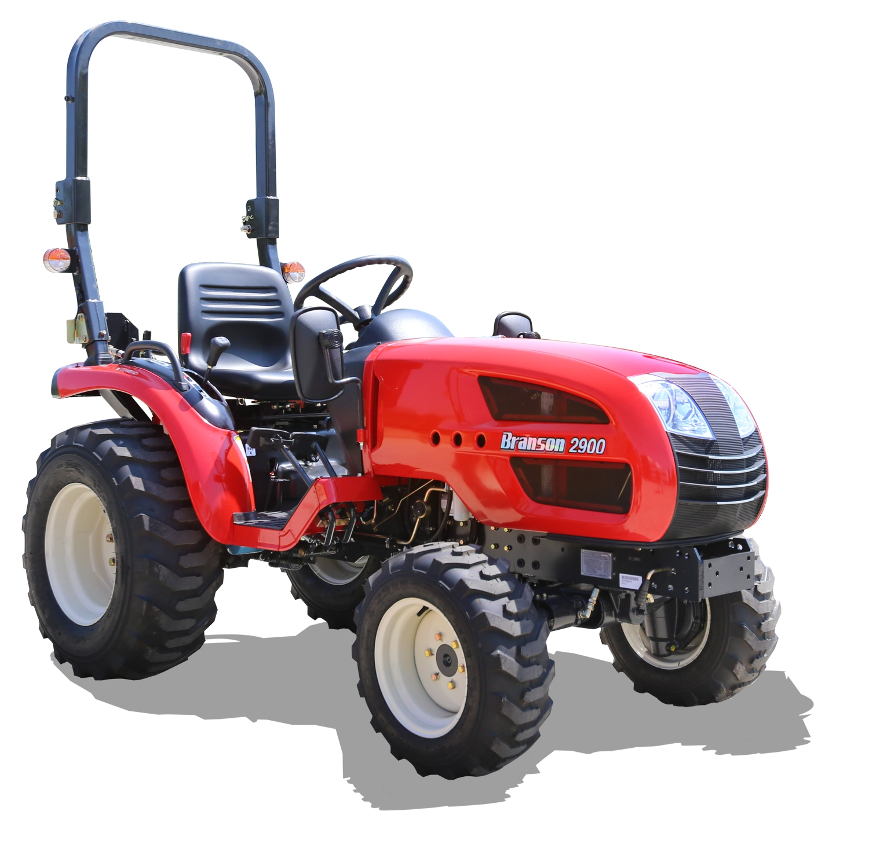
Teagle Toppers
Good selection in stock
5 foot cut,
5 feet 10 inch cut
Etc
POA

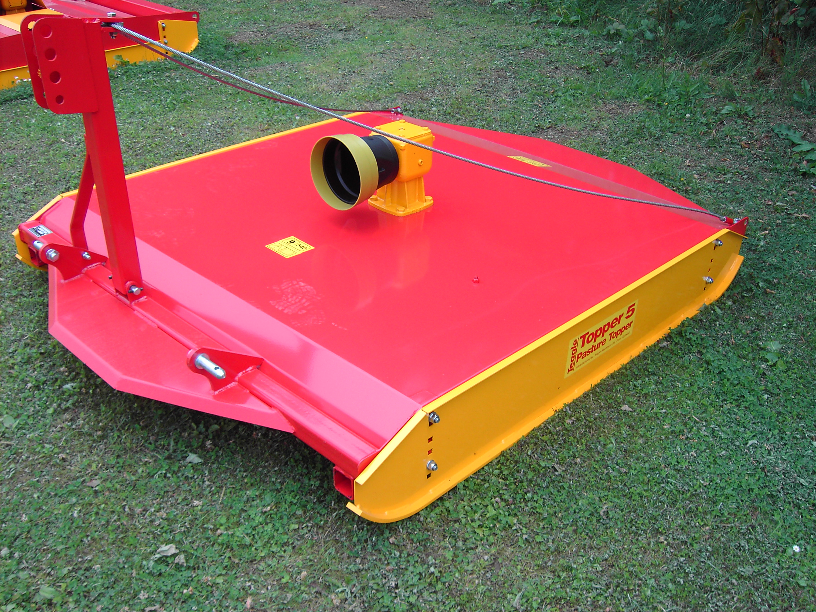

Ex Demo Branson Compact Tractor
28Hp
Roll bar
Hydrostatic

£9,875 + VAT

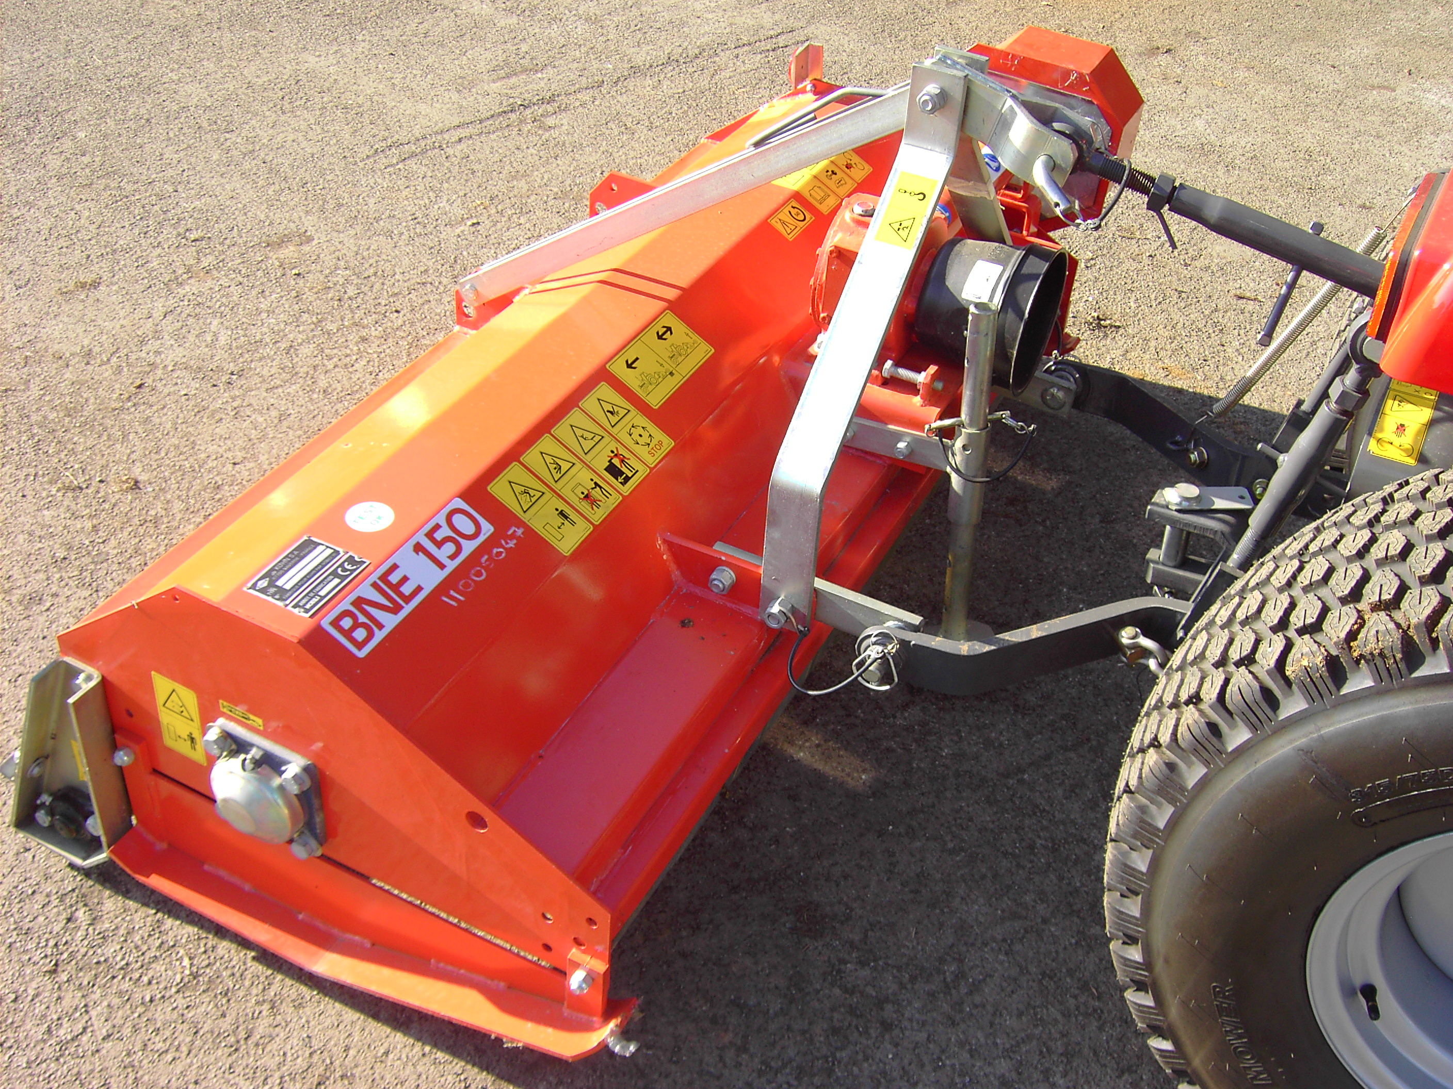
A Full range of Sicma and Teagle flail mowers
From £2340+VAT

Wanted, Good Used Quad Bikes

For Further Details Contact Bruce Hopkins 07860 809708 Domestic SEE OVER

